Miguel Millan

1/20/2019

Setting up Tensorflow in Windows

1. Install the latest version of python from <https://python.org>:

\*\* IMPORTANT!!! Make sure you download the 64bit version of python 3.6.x or lower!! Tensorflow hasn’t released binaries for 3.7.x yet.

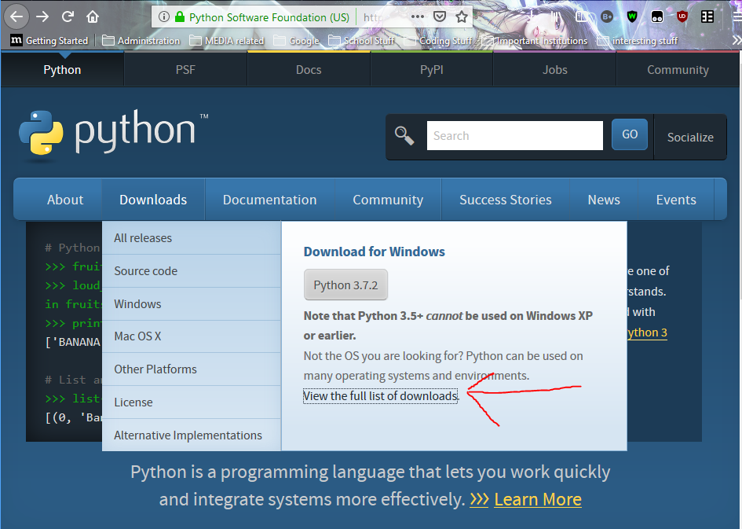

Click the latest release: 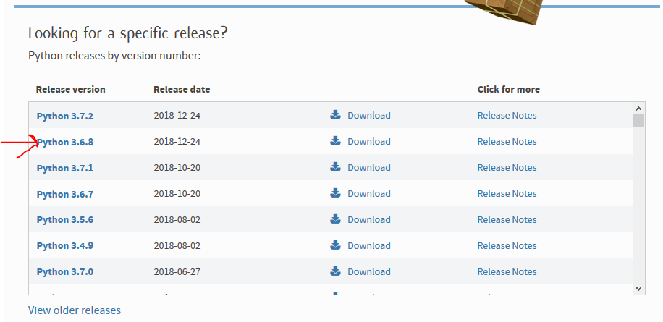

Select the 64bit installer for windows: 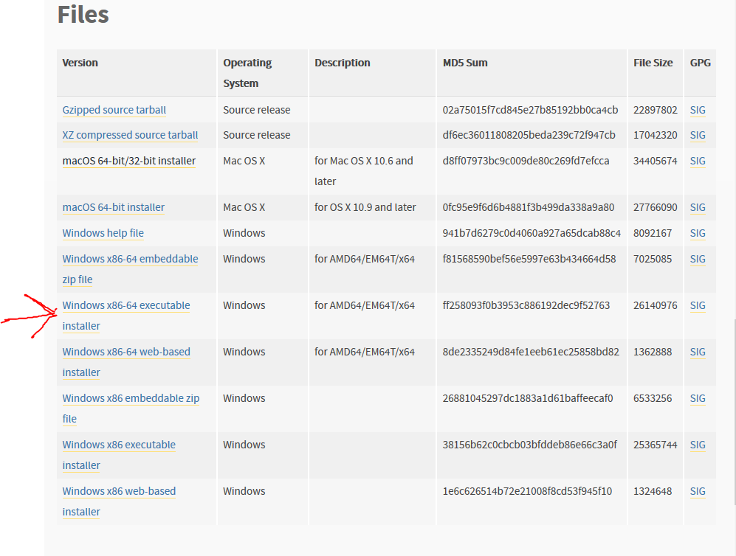

1. Run the installer. Add python to your PATH

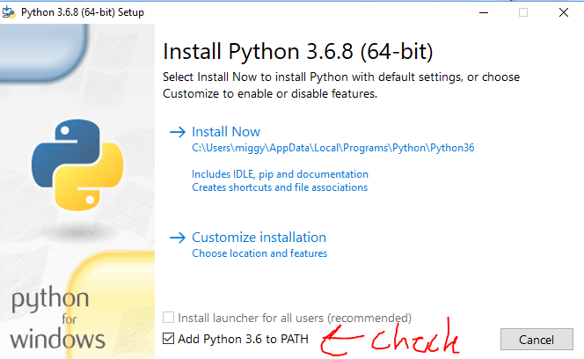

Optionally, choose your own path for Python by choosing a customized installation:

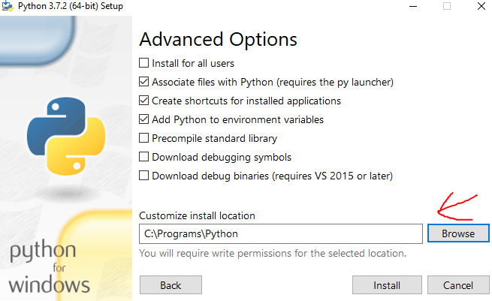

1. You can verify the installation by typing the following command in cmd or powershell: 
2. Install tensorflow:



1. If you get an error like this when trying to install tensorflow then you have installed the 32bit version of python and need to change to the 64bit version for windows, OR you are possibly using version 3.7.x for which there is not a tensorflow binary available yet.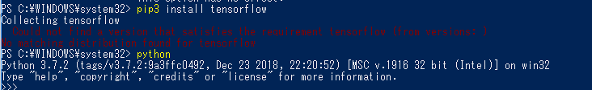

References:

<https://stackoverflow.com/questions/38896424/tensorflow-not-found-using-pip>

<https://www.python.org/downloads/release/python-368/>

<https://saintlad.com/install-tensorflow-on-windows/>

<https://www.tensorflow.org/install/pip>